Lesson 10

**Student Management**

You are to create a single web page that allow **C**reate, **R**ead, **U**pdate and **D**elete (CRUD) functions to the student database table.

**manageStudents.html**

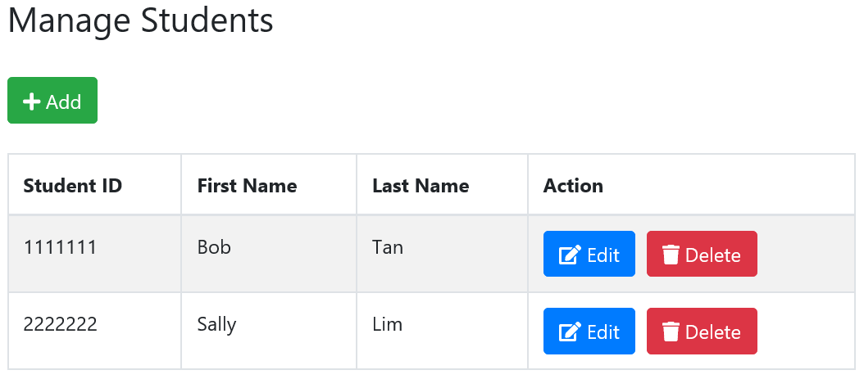

Upon clicking the Add button, a modal appears for data entry:

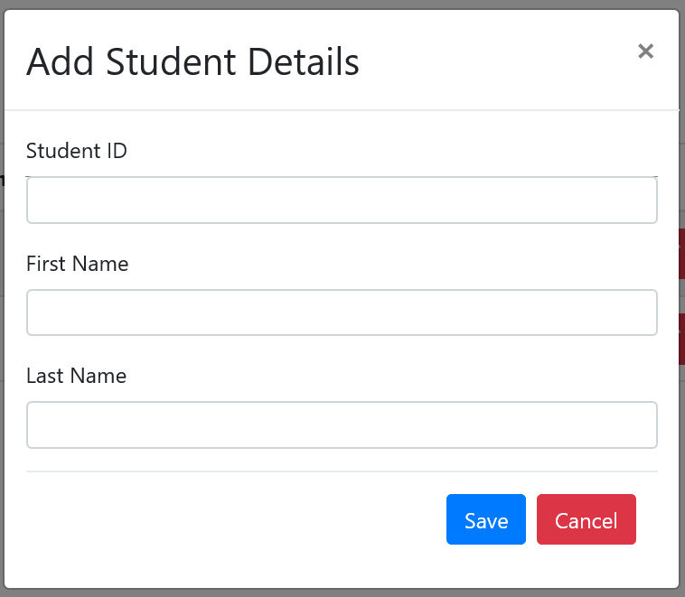

Upon clicking the Edit button, a modal appears for editing:

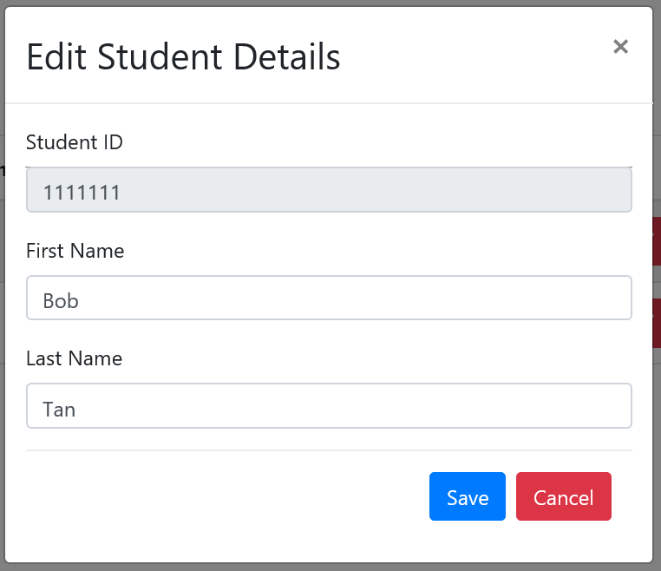

Upon clicking the Delete button, the app will ask for confirmation before deleting:

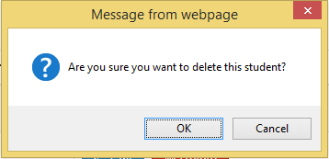

You are tasked to complete **manageStudent.html** and **manageStudent.js**.